Midterm User Instructions

We built a game based on the classic game titled Brick Breaker. For our pure data

patch we implemented four different sounds which respond to actions within the game. There is a background music theme and

sound effects for when the ball hits the paddle, a brick, and the space below the paddle.

Prerequisites:

* Pure Data, latest version
* Unity: build 2019.4.18f1 or above

Operation Instructions:

* Use Pure Data to open SoundImplementation.pd

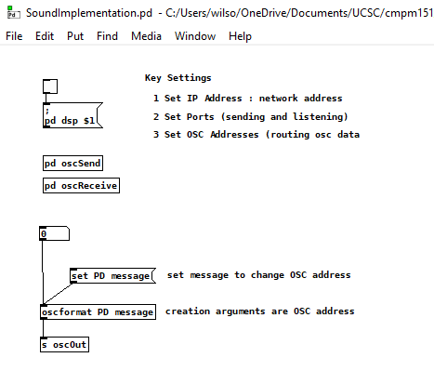

● Make sure that the box in the top left of the Pure Data patch is ticked to

enable audio in Pure Data.

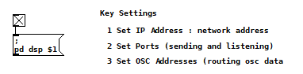

* Open the file using Unity, make sure the active screen is game, and press the triangle play button to start.

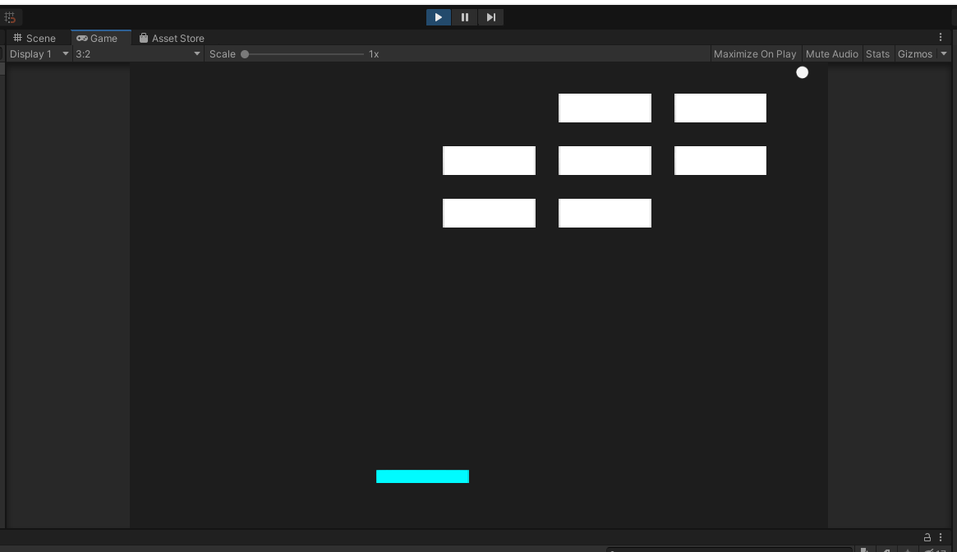

● Upon pressing play in Unity, audio triggers will be routed to Pure Data.

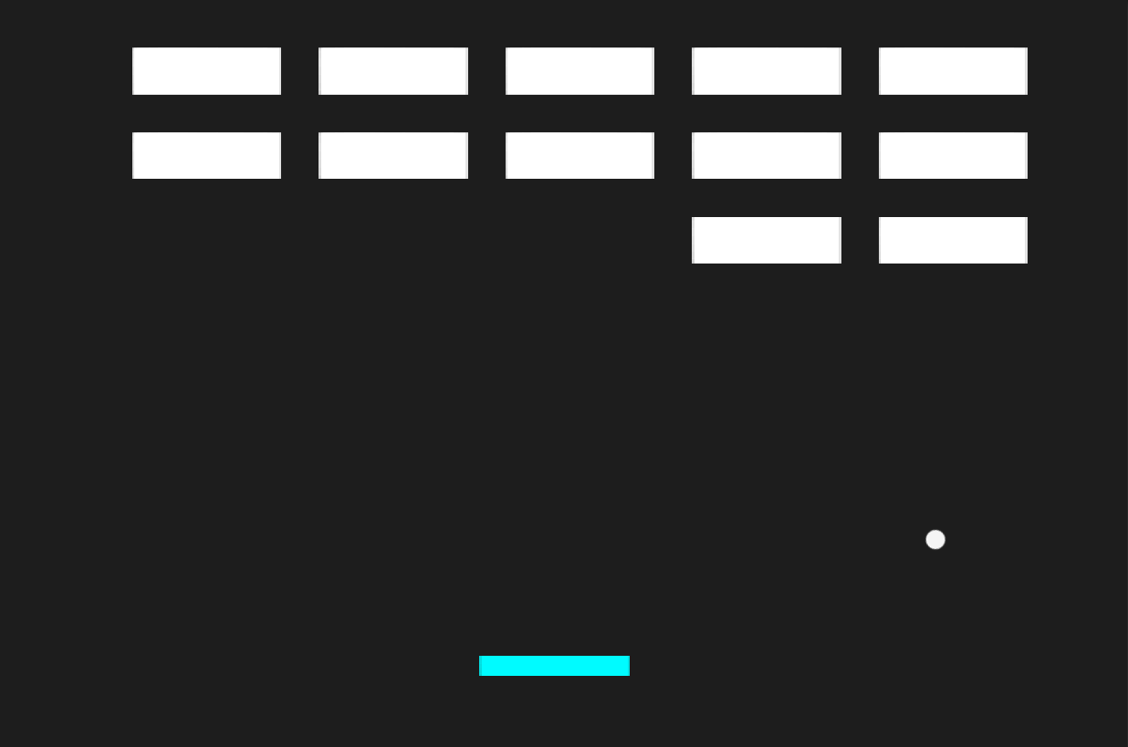

* Use arrow key “a” and “d” to move the paddle left and right respectively.
* The objective of the game is to use the paddle to bounce the ball around and break the bricks above.